**Amy Wang**

**MSCI 240 Fall 2018**

**Instructor: Dr Mark Hancock**

**November 26th, 2018**

**Project 3**

**Code:**

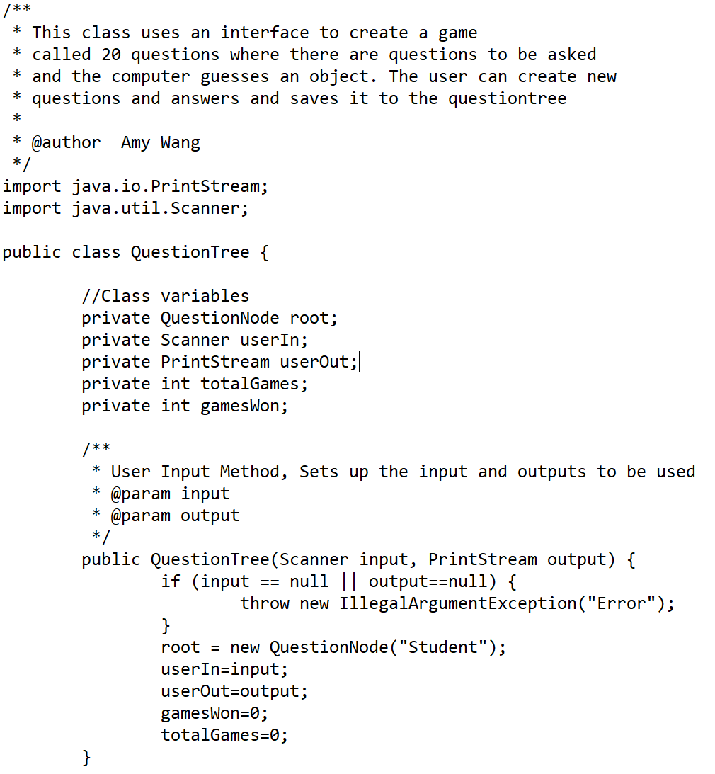

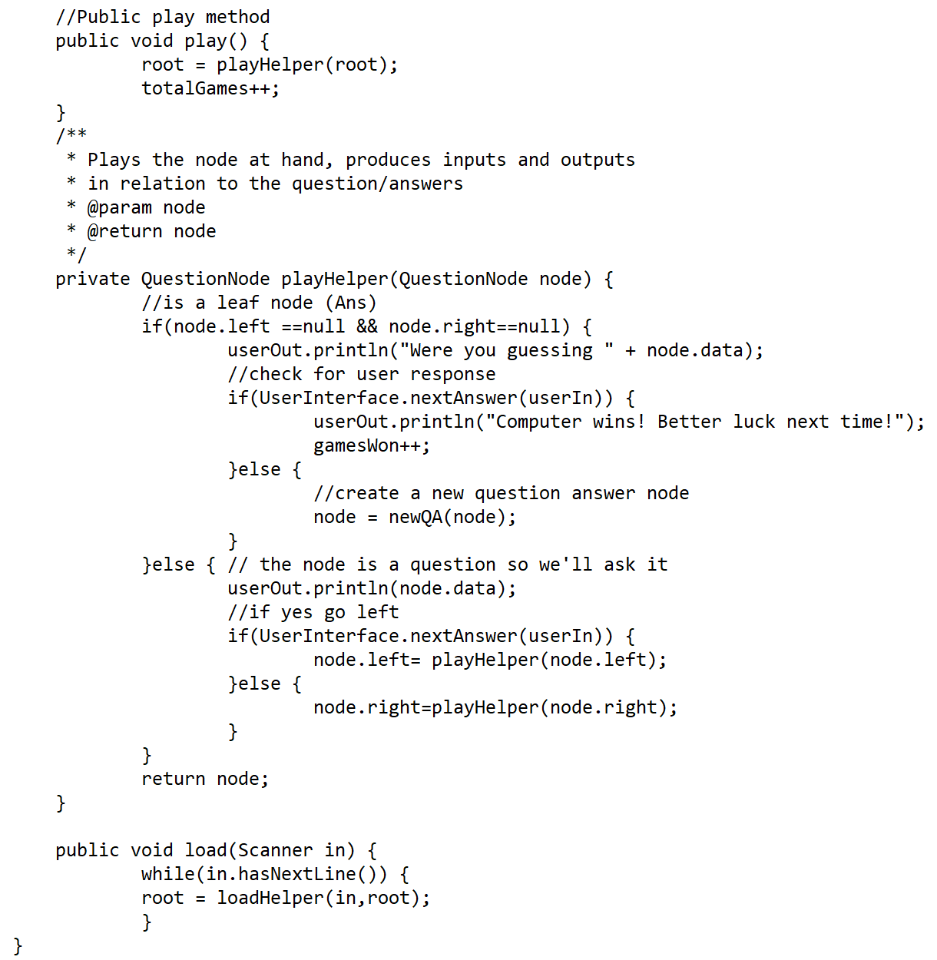

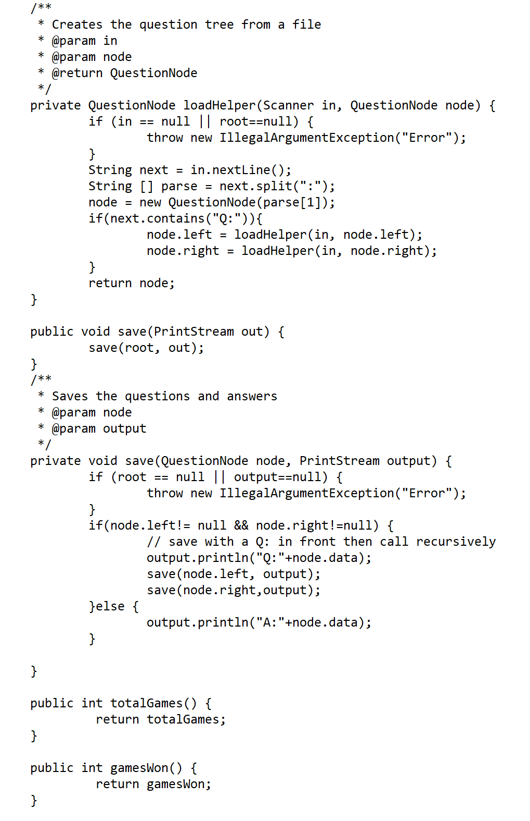

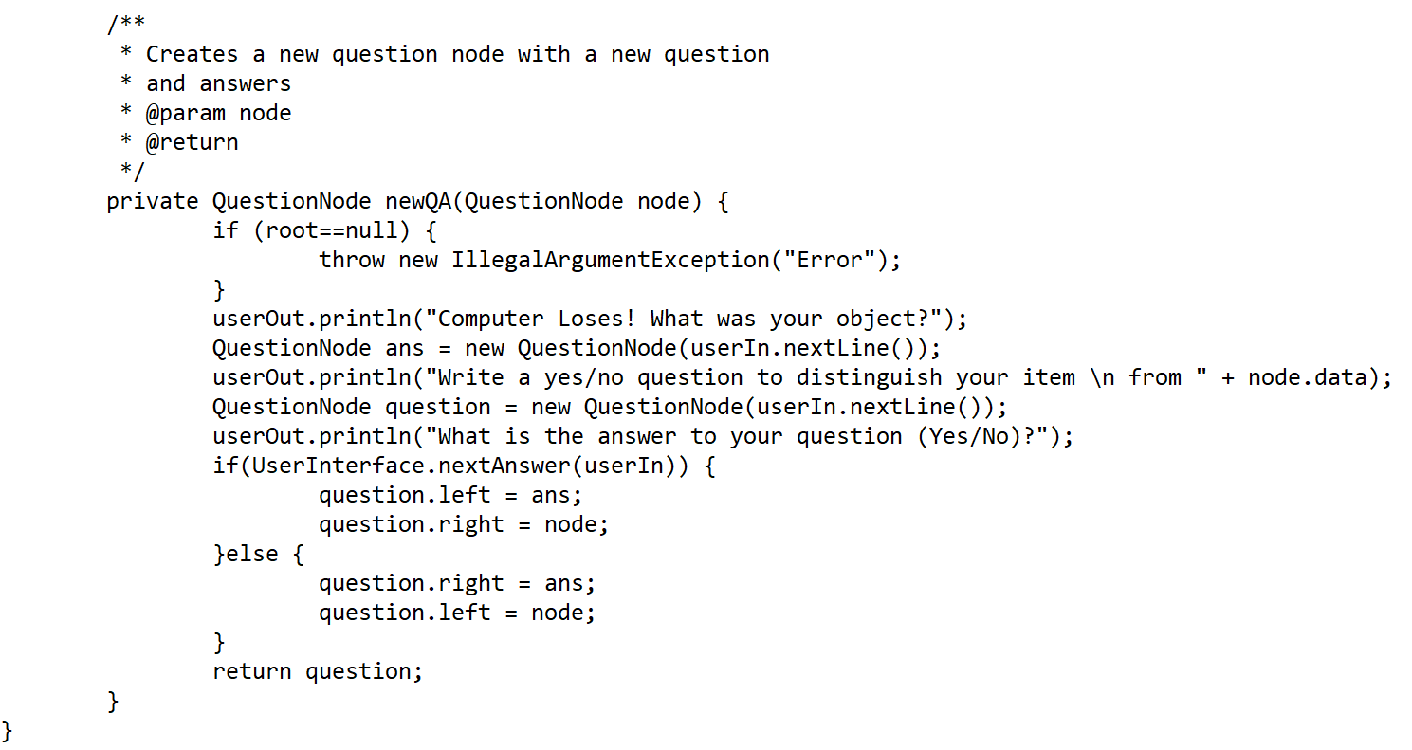

Text (Question tree):

# 